
Company
Logotype

Cone Beam Computed Tomography- Report



Porur Dental X-rays & CBCT

Patient Name : Mrs. Aruna Devi | Date of Report : 28.04.2025
Age/ Gender : 42 years/ Female | Region of Interest : CBCT Full Skull
Referring doctor: Dr. Vikram Vishwanath | Indication : Implant assessment
Clinical Notes: Nil
PATIENT INFORMATION

CBCT- Full Skull provided
CBCT – IMAGE DETAILS

RADIOGRAPHIC INTERPRETATION

- Complete loss of crown and root structure in relation to 16, 17, 18, 31, 37, 41, 42, 46.
- The alveolar ridge in relation to the maxillary and mandibular alveolar ridge is present with resorptive changes.
- Bone type in relation to 11, 12, 13, 14, 21, 22, 23, 24, 25 region is D3
- Bone type in relation to 16, 17, 26, 27 region is D4
- Bone type in relation to mandibular arch is D4

IMPLANT ASSESSMENT

 | 11 region | 12 region | 13 region | 14 region | 21 region | 22 region | 23 region | 24 region
Sub-Crestal | 3.7 | 5 | 3.2 | 4.8 | 2.7 | 3.6 | 3 | 5.1
Mid- Crestal | 2.8 | 3.7 | 3.9 | 4.1 | 3.8 | 4.7 | 3.6 | 6.1
Distance between the alveolar ridge and Floor of the Nasal cavity (in mm) | 16.6 | 12.8 | 14.5 | 10.4 | 13.5 | 12.4 | 10.9 | 9.8

 | 15 region | 16 region | 17 region | 25 region | 26 region | 27 region
Sub-Crestal (in mm) | 5.1 | 8.3 | 11.1 | 4.7 | 8.2 | 9.7
Mid- Crestal (in mm) | 5.6 | - | - | 5.6 | - | -
Distance between the alveolar ridge and floor of the maxillary sinus (in mm) | 13.7 | 7.7 | 5.7 | 12.7 | 6.4 | 8.1

 | 31 region | 32 region | 33 region | 34 region
Sub-Crestal (in mm) | 3 | 3.6 | 4.2 | 5.4
Mid- Crestal (in mm) | 3.7 | 4.6 | 4.7 | 6.5
Distance between alveolar ridge and the inferior border of mandible (in mm) | 23.8 | 23.5 | 20.9 | 22.7

 | 41 region | 42 region | 43 region | 44 region
Sub-Crestal (in mm) | 3.7 | 3.1 | 4.1 | 4.6
Mid- Crestal (in mm) | 3.5 | 4 | 4 | 5.4
Distance between alveolar ridge and the inferior border of mandible (in mm) | 21.9 | 21.4 | 22.5 | 23.8
 | 45 region | 46 region | 47 region
Sub-Crestal (in mm) | 6.6 | 6.2 | 8.6
Mid- Crestal (in mm) | 8.4 | 7.5 | 10
Distance between alveolar ridge and the inferior alveolar nerve canal (in mm) | 7.7 | 11.9 | 9
Distance between alveolar ridge and the inferior border of mandible (in mm) | 23.4 | 21.9 | 19.1

 | 35 region | 36 region | 37 region
Sub-Crestal (in mm) | 6.3 | 9.3 | 6.7
Mid- Crestal (in mm) | 8 | 9.1 | 8.1
Distance between alveolar ridge and the inferior alveolar nerve canal (in mm) | 10 | 11.6 | 12.7
Distance between alveolar ridge and the inferior border of mandible (in mm) | 21.9 | 19.1 | 23.3

RADIOGRAPHIC IMPRESSION

- Partially edentulous maxillary and mandibular arch.
- Generalized chronic periodontitis.

Kindly correlate with clinical findings


IMAGES FOR REFERENCE

RECONSTRUCTED PANORAMIC VIEW

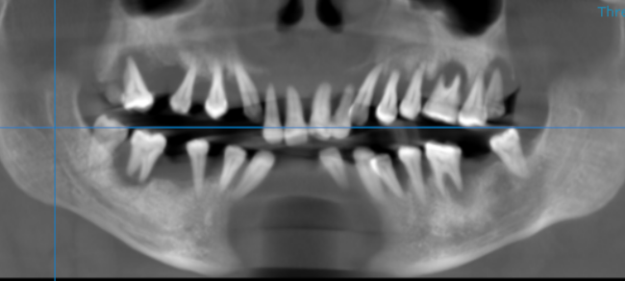

3-DIMENSIONAL VIEW

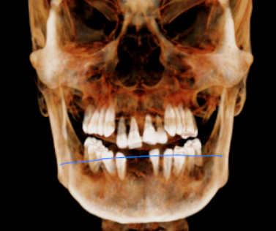

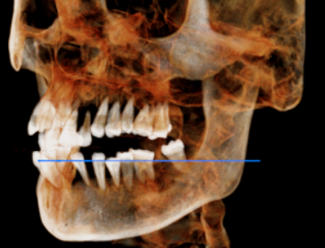
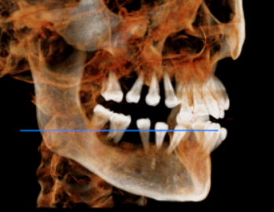

CROSS SECTIONAL VIEW

11 region | 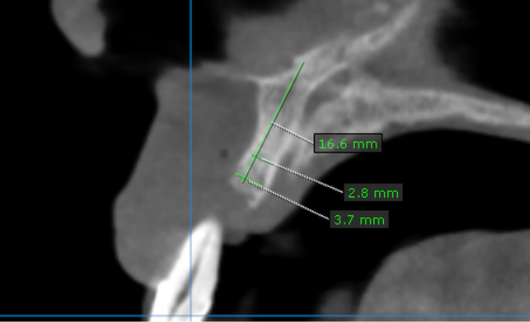
12 region | 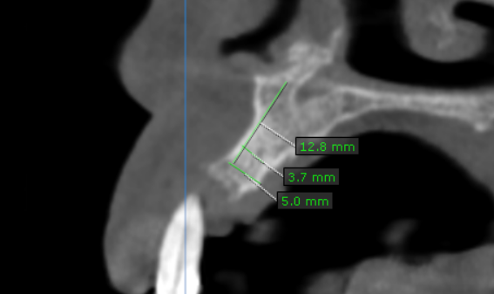
13 region | 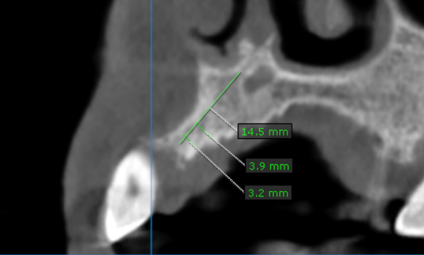
14 region | 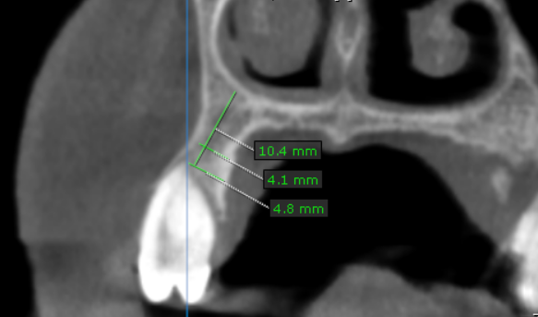
15 region | 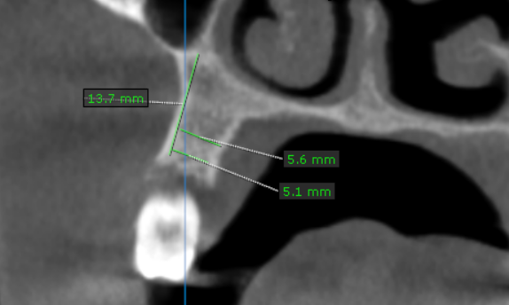
16 region | 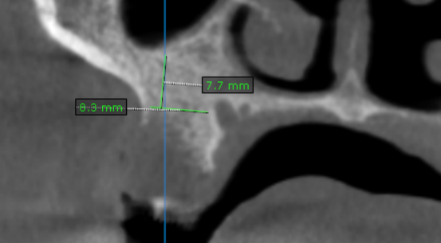
17 region | 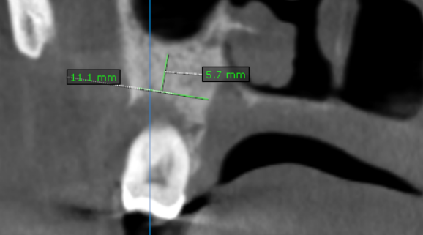
21 region | 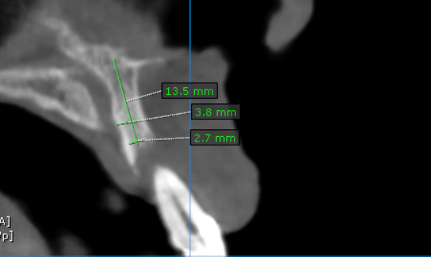
22 region | 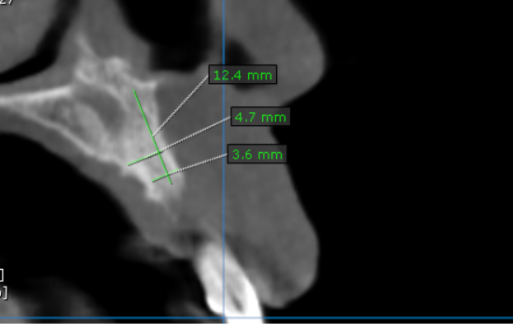
23 region | 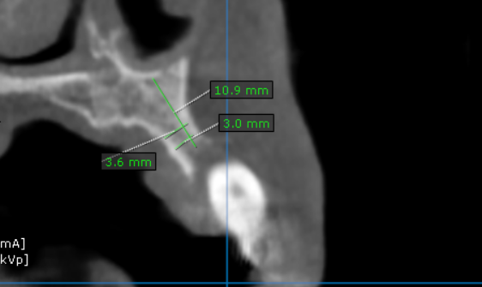
24 region | 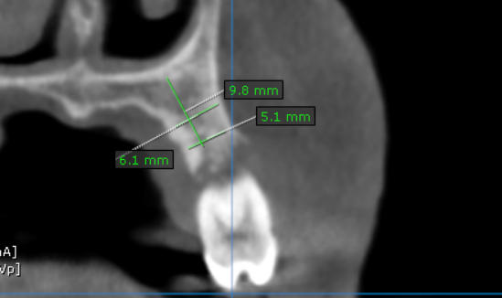
25 region | 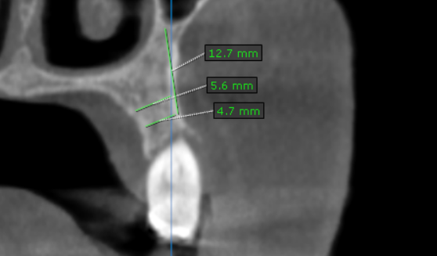
26 region | 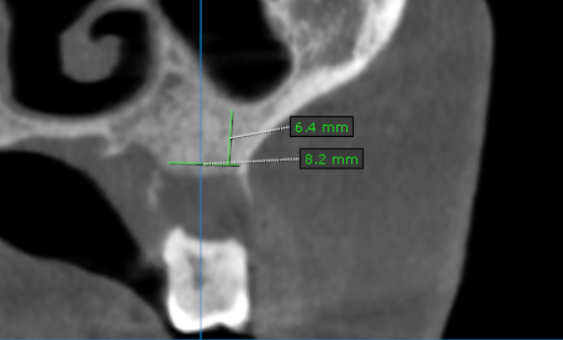
27 region | 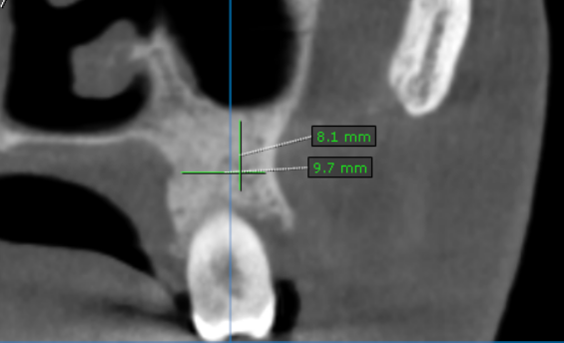
31 region | 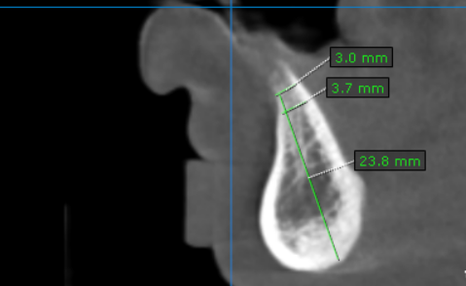
32 region | 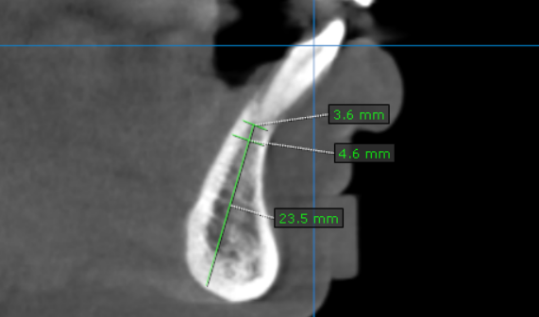
33 region | 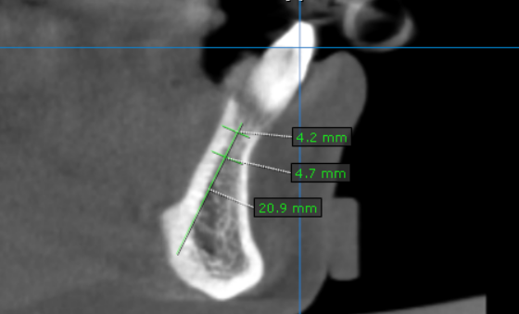
34 region | 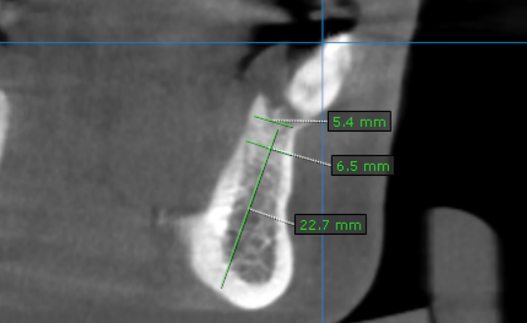
35 region | 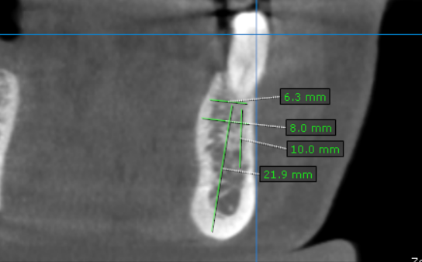
36 region | 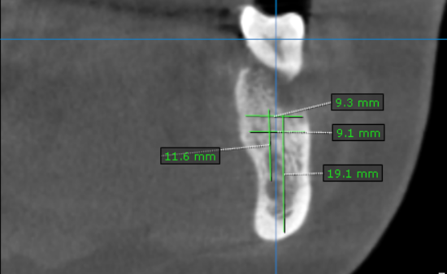
37 region | 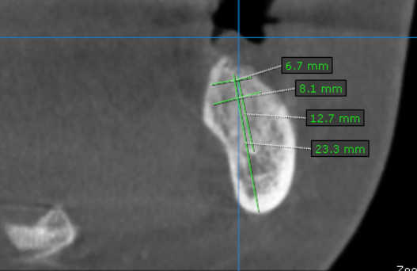
41 region | 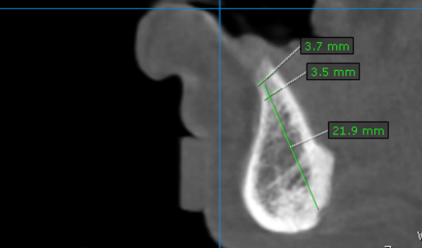
42 region | 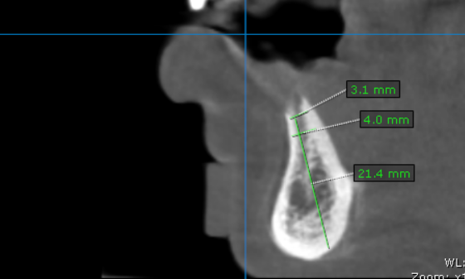
43 region | 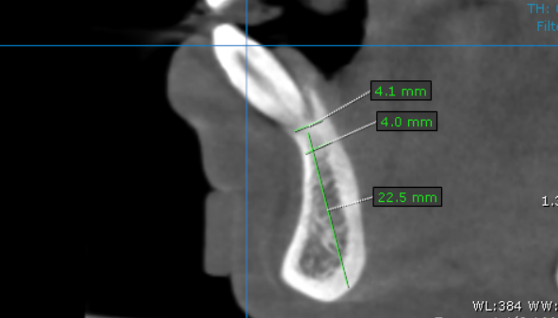
44 region | 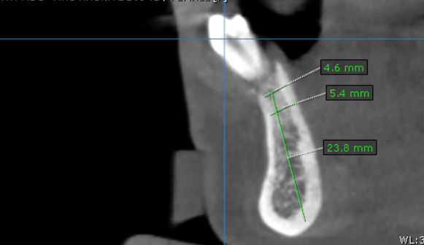
45 region | 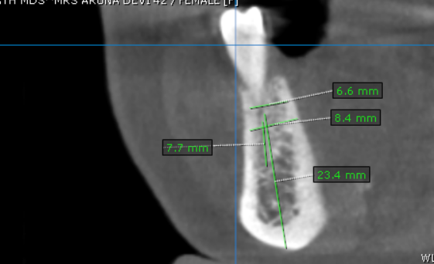
46 region | 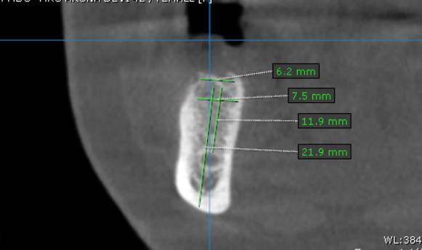
47 region | 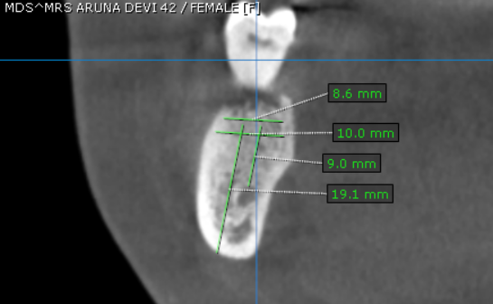

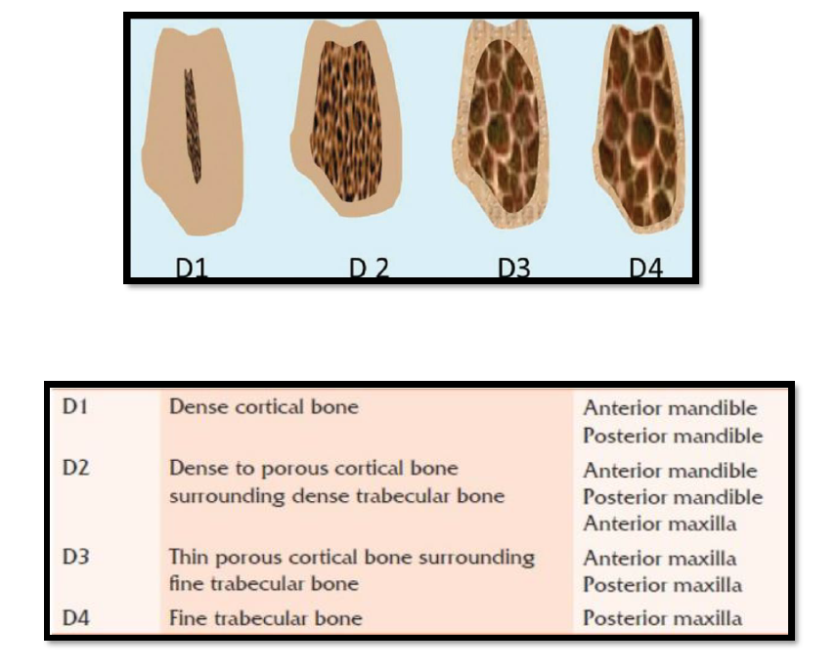
REFERENCE

**** End of report ****

